Development Asia – Case Study

This case study template aims to capture the effectiveness of a completed or ongoing program/project and its practical lessons in addressing economic and social development challenges, no matter how small or big.

This template may also be used to capture the lessons and outcomes of technology applications in addressing development challenges. From low-end to high-end technology, we aim to highlight its relevance, effectiveness, cost, and innovative features by discussing the outcome of actual application.
Note to vendors: Please focus on stories and experiences from the actual application of your technology and not on business promotion.)

View sample case studies on the website. For more information, contact info@development.asia.

- Basic Information

1.1. Expert’s bio
Expert  (50 words for each bio) | Please provide a brief bio of the expert(s) associated with the content. The institution that holds the copyright of the original content may be listed along with the expert. Please provide a brief introduction of the institution.  Please include a link to the expert's LinkedIn page if available. Other social media links and contact information are welcome.  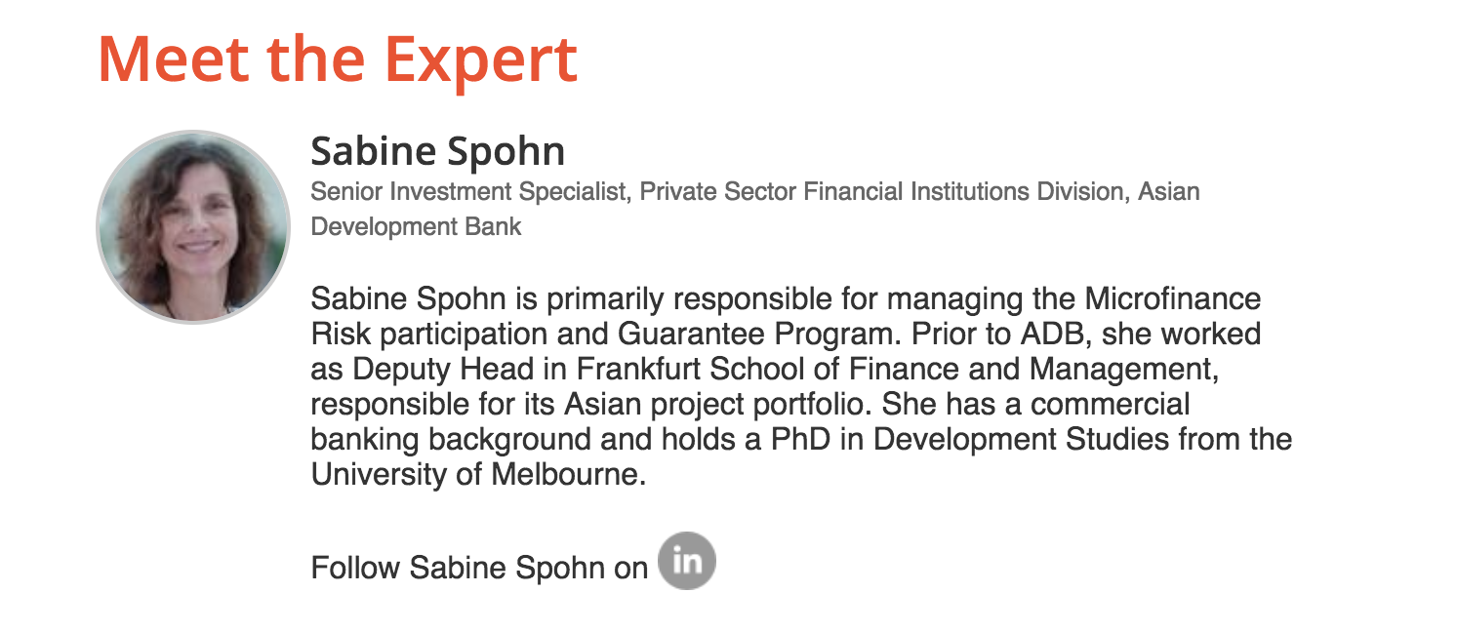

1.2. Check box for sectors
Sector | Which sector does this article primarily address? You may select more than one but not more than three sectors.

 | Agriculture and natural resources |  | Health
 | Capacity development |  | Industry and trade
 | Civil society |  | Information and communications technology
 | Climate change |  | Poverty
 | Economics |  | Private sector development
 | Education |  | Regional cooperation and integration
 | Energy |  | Social development and protection
 | Environment |  | Transport
 | Finance sector development |  | Urban development
 | Gender |  | Water
 | Governance and public sector management

1.3. Check box for SDGs
SDGs | Choose which Sustainable Development Goal (SDGs) is most relevant to this article. Select up to 3 SDGs only.

 | Goal 1: No Poverty |  | Goal 10: Reduced Inequalities
 | Goal 2: Zero Hunger |  | Goal 11: Sustainable Cities and Communities
 | Goal 3: Good Health and Well-being |  | Goal 12: Responsible Consumption and Production
 | Goal 4: Quality Education |  | Goal 13: Climate Action
 | Goal 5: Gender Equality |  | Goal 14: Life Below Water
 | Goal 6: Clean Water and Sanitation |  | Goal 15: Life on Land
 | Goal 7: Affordable and Clean Energy |  | Goal 16: Peace, Justice and Strong Institutions
 | Goal 8: Decent Work and Economic Growth |  | Goal 17: Partnerships for the Goals
 | Goal 9: Industry, Innovation and Infrastructure

1.4. Keywords
Keywords | Add 5–10 keywords or phrases, including the topic and country/region (if applicable) to be included in the metadata.

1.5. List of attachments
Photos and other materials | - Portrait photo of expert or experts and/or high-resolution logo of institution (see 1.1).  - Please provide a photo that is most relevant to the content with a brief caption that tells the location and context of the photo. If you are submitting a copyrighted photo, please ask the copyright owner to sign the attached consent form.  - Photo caption:  - Context:  - Date:  - Location:  - You may submit additional materials that can support the content, such as annexes, infographics, videos, before-and-after photos, design plans, and other materials.

- Content

  - Overview
Overview  (120 words) | Give the key points of the case study. Introduce the main challenge and solution.  - What is the project/program and why is it important?  - When did it start and when is it expected to end?  - How will it solve a problem or improve a situation?  - Which institutions are involved and who are the stakeholders?

  - Development Challenges
Challenges  (120 words) | Describe the nature and type of economic, social, environmental, and/or other development challenges. You may refer to the Sustainable Development Goals (SDGs) in framing the challenges.

2.2. Context
Context  (200 words) | Concisely describe, as background information, the context and/or constraints in which the challenges may be better understood. Identify the perceived causes or issues contributing to the complexity of identified development challenges: economic, social, geographical, environmental, institutional, cultural, and/or international. Please do not list all the possible causes you have identified; only highlight those major causes your solution has tried to address.  Always remember how you define the problem would dictate the solution you choose.

2.3. Solutions
Solutions  (300 words) | Describe how the program/project addresses the above challenges. More specifically, highlight the logic and design of the program/project in relation to the context and constraints. Please also discuss the alternative solutions/options that were considered.  Please highlight innovative features of the project if there are any and explain what makes them innovative.

2.4. Actual outcomes
Results  (200 words) | Did the program and/or project achieve the intended outcome? Support your assessment of the results with quantifiable outcomes, if available. Please include unintended outcomes and/or other unforeseen side effects if any. If you choose to discuss shortcomings and/or failures, please also explain the reasons behind these.

2.5. Lessons
Lessons  (300 words) | Describe key factors to the success and/or failure of the program and/or project. Please also identify the things you could have done differently. Describe your recommendations to your peers who may be in a similar situation. Focus on practical tips and insights that may be applied to similar projects.

2.6. Resources
Resources | Please provide a list of references, including the original document if applicable, and/or recommended content (journal articles, publications, etc.) on approaches and solutions addressing similar challenges in a different context and with different constraints.  For books, use the following model for format and punctuation.  Author. Year. Title in Italics. City: Publisher.  Author. Year. Title in Italics. City: Publisher. page number.  For periodicals, use the following model for format and punctuation.  Author. Year. Title of Article. Journal or Newspaper Title in Italics. Volume  number (issue number).  Author. Year. Title of Article. Journal or Newspaper Title in Italics. Volume  number (issue number). page number.  Please provide links for resources that are available online.

2.7. Program/Project at a glance (if applicable)
Program/Project Snapshot | - Main goal  - Targets  - Technical details: Any information relevant to understanding the scale of a program/project, e.g. how many kilometers of a road with how many lanes.  - Actual/projected total cost in local currency and USD (use the exchange rate at the closing date of a program/project)  - Source of financing  - Duration in number of years, including start and end date.  - Planning Agency  - Implementing/Executing Agency  - Other stakeholders: e.g. affected persons, NGOs.

2.8. Blurb
Short one-sentence blurb  (150 characters, including spaces) | Write a short, relevant summary to inform and interest users. This one-sentence blurb will be displayed on the homepage and search results page of not only the Development Asia website but also search engines, such as Google.  A good blurb that contains relevant keywords will help researchers on the internet find your case study.  Our editors can help you optimize your one-sentence blurbs for search engines.

2.9. Title
Suggest a title  (15 words) | Describe the goal of your program or project in an interesting way.

- Additional Content (Optional)

3.1. Innovative feature
Innovative feature  (150 words) | Highlight an aspect of the program/project that demonstrates an innovative approach. Please explain why it is considered an innovation in the context of the program/project.

3-2. Additional information
Additional information  (500 words) | Please provide any other relevant information that may be helpful in understanding the complexity of the development challenge and/or applied solutions during the whole program/project cycle: design, decision-making, implementation, operation, and monitoring/evaluation.

